Deticated VM hosts with ORM stack

Contents

1. Introduction 3
2. Workflow diagram to deploy the stack 3
3. Create stack for Dedicated VM hosts 4
4. Plan the Job 7
5. Apply the Job 8
6. Destroy the stack 9

Introduction

Dedicated virtual machine hosts let user run Oracle Cloud Infrastructure Compute virtual machine (VM) instances on dedicated servers that are a single tenant and not shared with other customers. Use dedicated virtual machine hosts to meet compliance and regulatory requirements for isolation that prevent user from using shared infrastructure. Also use dedicated virtual machine hosts to meet node-based or host-based licensing requirements that require user to license an entire server.

Workflow diagram to deploy the stack

Below diagram shows how the Terraform Artifact are applied in the OCI. While creating a ORM stack, using terraform deliverables Init, Plan and Apply is the flow to provision the resource in the OCI. We can have the deliverables in any of below.

- GitLab/GitHub Repo
- Bitbucket
- Can be in folder/.zip in the local disk
- Object Storage Bucket
- Can be in compartment
- Oracle provided Template

Prerequisites:
Support and Limitations
Shapes and capacity: When you create a dedicated virtual machine host, you select a shape for the dedicated virtual machine host. The shape determines how much capacity is available and what types of instances can be launched on the host. Note that there is a difference between the number listed for billed OCPUs compared to available OCPUs. This is because some OCPUs are reserved for virtual machine management.
When you launch an instance on a dedicated virtual machine host, you can choose any of the VM shapes that are supported for that host.
You can mix VM instances with different supported shapes on the same dedicated virtual machine host. The size of each instance might impact the maximum number of instances that you can place on the dedicated virtual machine host. For more information, see Optimizing Capacity on a Dedicated Virtual Machine Host.
Billing: You are billed for the dedicated virtual machine host as soon as you create it, but you are not billed for any of the individual VM instances you place on it. You will still be billed for image licensing costs if they apply to the image you are using for the VM instances.
Supported features: Most of the Compute features for VM instances are supported for instances running on dedicated virtual machine hosts.
Shape | Instance Type | Billed OCPU | Usable OCPU | Total Memory (GB) | Usable Memory (GB) | Supported Shapes for Hosted VMs
DVH.Standard2.52 | X7-based VM host | 52 | 48 | 768 | 736 | VM.Standard2 series
DVH.Standard3.64 | X9-based VM host | 64 | 60 | 1024 | 960 | VM.Standard3 series
DVH.Standard.E2.64 | E2-based VM host | 64 | 59 | 512 | 480 | VM.Standard.E2 series
DVH.Standard.E3.128 | E3-based VM host | 128 | 124 | 2048 | 1912 | VM.Standard.E3 series
DVH.Standard.E4.128 | E4-based VM host | 128 | 124 | 2048 | 1912 | VM.Standard.E4 series
DVH.DenseIO2.52 | X7-based dense I/O VM host | 52 | 48 | 768 | 736 | VM.DenseIO2 series
DVH.Optimized3.36 | X9-based optimized VM host | 36 | 32 | 512 | 472 | VM.Optimized3 series

Create stack for Dedicated VM hosts

Go to OCI Console Developer Services Resource Manager Stacks select the compartment Create Stack

My Configuration Folder Browse Select the “dedicated vm” folder that contains the terraform Upload

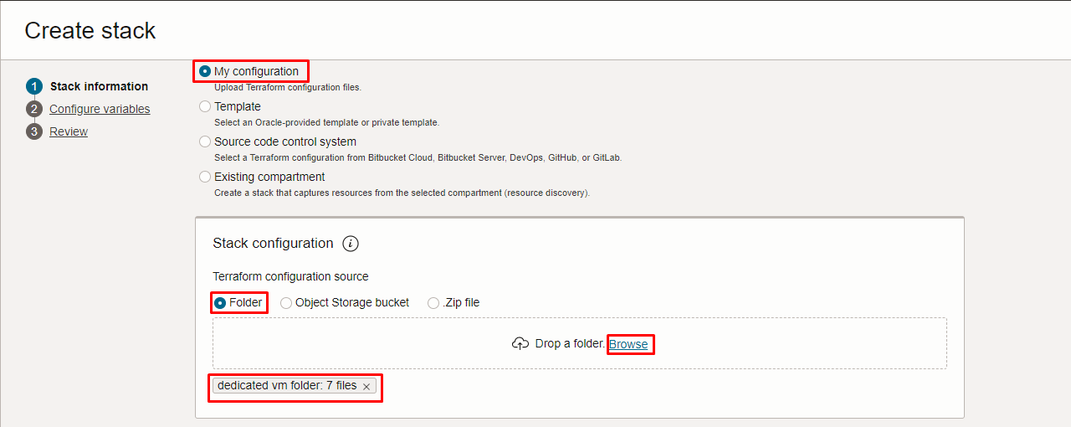
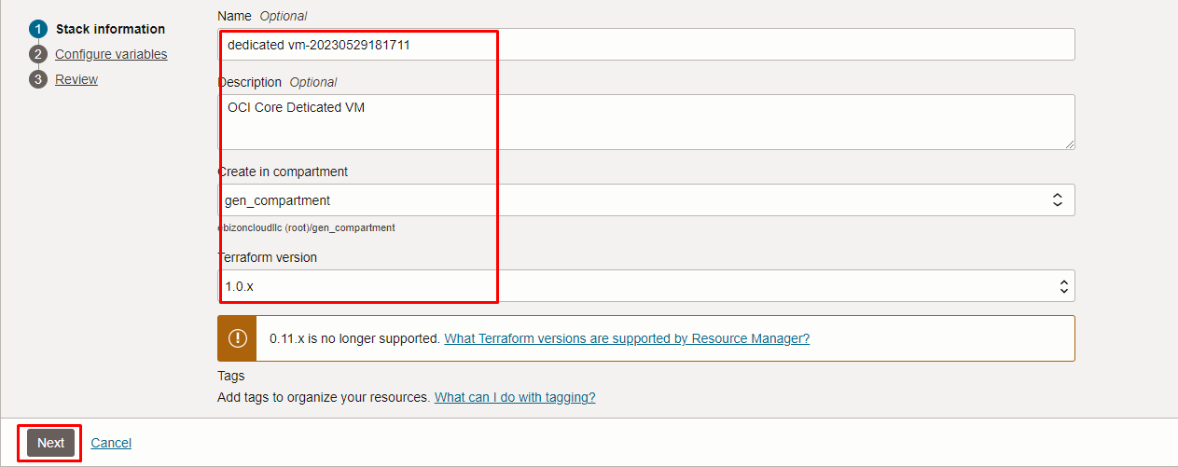

Click “NEXT”
Select the parameters as per the below screen,

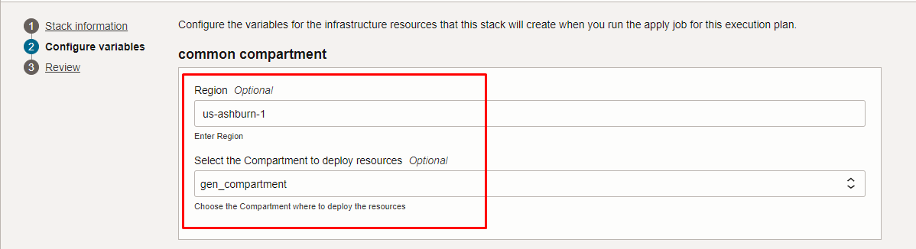
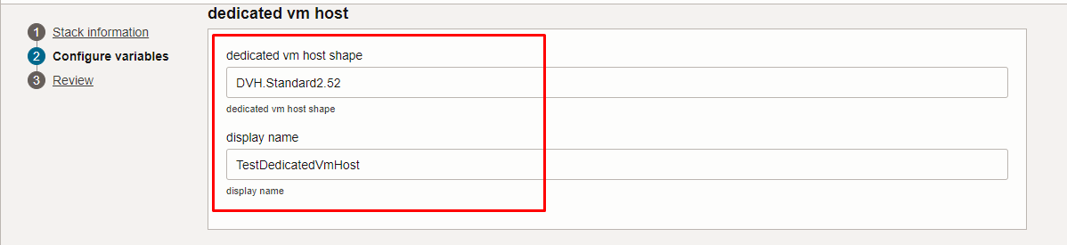

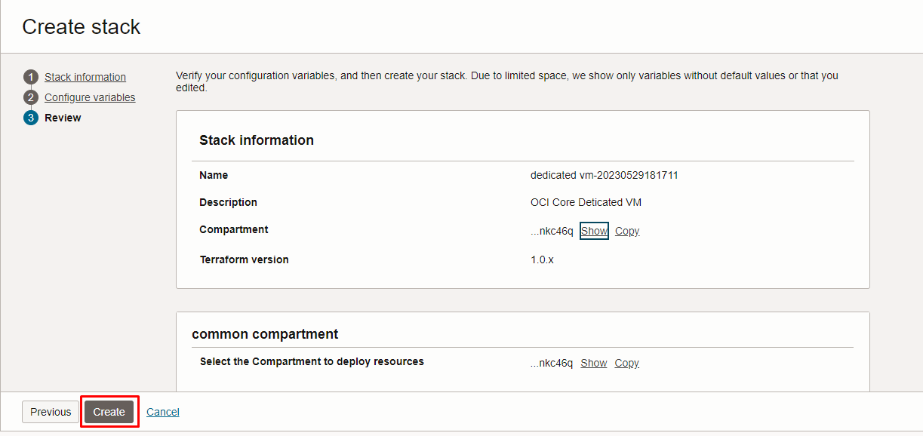

Click “NEXT” Click “CREATE”

Plan the Job

Click the “Plan”

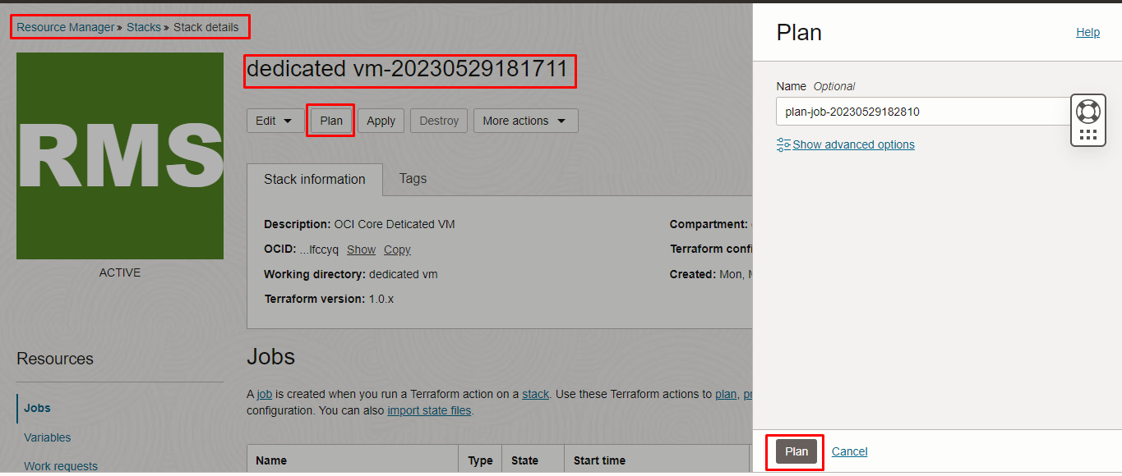

Verify the Plan is successful.

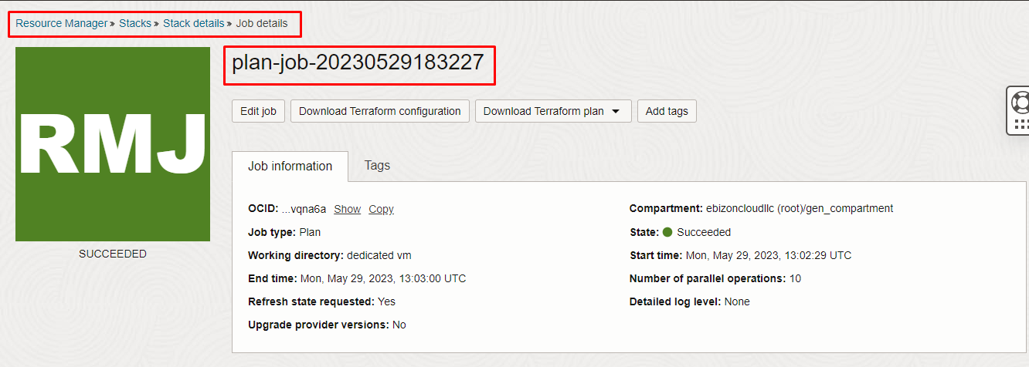
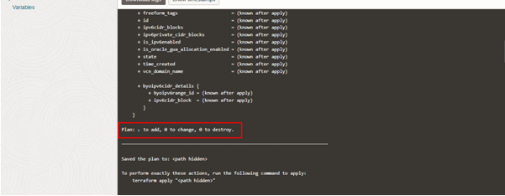

**END**

